PYTHON 程序设计

课程设计报告

文档类型： 一 个人

专业： 软件18 班级： 1

学号： 2018010160933

设计人： KAFLE SAMRAT

山 东 科 技 大 学

**Number Guessing Game**

Key Points:

(1) Master the method of using a function randint to generate a random number, master the use of variable assignment operations .  
(2) Master the use of if-lfelse conditional statements.

(3) Master the while loop, and master the combined application of conditional statements and loop statements.

(4) Master the functions of (GUI library of Python -) Tkinter.

Specifications:

By using Tkinter(python GUI library) develop a “guess the number” game (with window interface), the game computer randomly generated within 1000 numbers, players to guess, if the number is too large or too small will be prompted, program statistics players guess the number of times.

(使用tkinter开发猜数字游戏（带窗口界面），游戏中计算机随机生成1000以内数字，玩家去猜，如果猜的数字过大或过小都会有提示，程序统计玩家猜的次数。)

code:

import tkinter as tk

import random

#variable initialization

number = random.randint(0,1000)

running = True

num = 0

n_maxn = 1000

n_minn = 0

#Exit

**def** e_BtnClose(event):

root.destroy()

#Game Rule and main game function

**def** e_BtnGuess(eent):

**global** n_maxn

**global** n_minn

**global** num

**global** running

if running:

var_a = int(entry_a.get())

if var_a == number:

labelqval("Congratulations Your Answer is Correct！")

num += 1

running = False

numGuess()

elif var_a < number:

if var_a > n_minn:

n_minn = var_a

num += 1

labelqval("Your number is smaller!, please enter any number between "+str(n_minn)+" and "+str(n_maxn)+" : ")

else:

if var_a < n_maxn:

n_maxn = var_a

num +=1

labelqval("Your number is bigger!, please enter any number between "+str(n_minn)+" and "+str(n_maxn)+" : ")

else:labelqval('You already answered!')

#Count the number of Guesses

**def** numGuess():

if num == 1:

labelqval('Congratulations! Your answer is correct in the first attempt.')

print("You use : "+str(num)+ " number of gusses.")

#Main GUI structure

**def** labelqval(Teeext):

label_val_q.config(label_val_q,text = Teeext)

root = tk.Tk(className="The Number Game")

root.geometry("400x90+200+200")

label_val_q = tk.Label(root,width = "80")

label_val_q.pack(side = "top")

entry_a = tk.Entry(root,width = "40")

btnGuess = tk.Button(root,text = "Guess")

entry_a.pack(side = "left")

entry_a.bind('<Return>',e_BtnGuess)

btnGuess.bind('<Button-1>',e_BtnGuess)

btnGuess.pack(side = "left")

btnClose = tk.Button(root,text = "Exit")

btnClose.bind('<Button-1>',e_BtnClose)

btnClose.pack(side = "left")

labelqval("Please enter any integer between 0 and 1000: ")

entry_a.focus_get()

print(number)

root.mainloop()

Result:

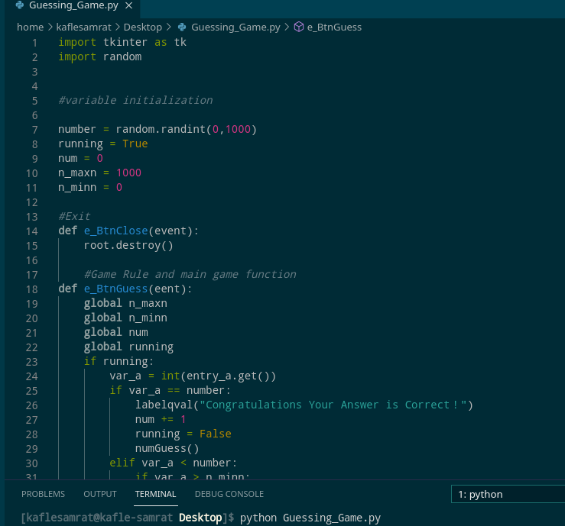

.

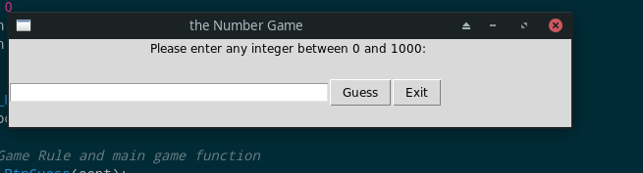

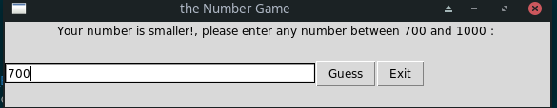.

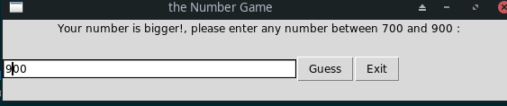.

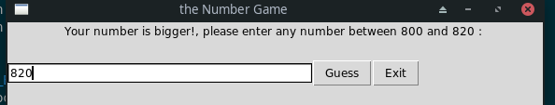

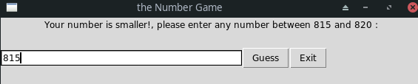.

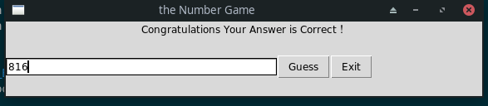

.

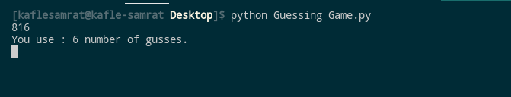.

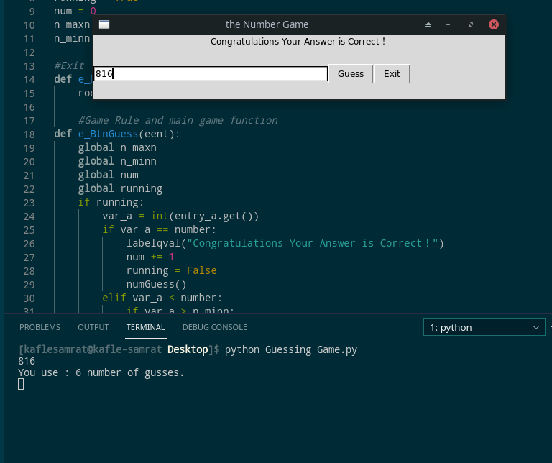.

If You give correct your Answer in first attempt:

